**Project Design Phase-II**

**Data Flow Diagram & User Stories**

|  |  |
| --- | --- |
| Date | 31 January 2025 |
| Team ID |  |
| Project Name |  |
| Maximum Marks | 4 Marks |

**Data Flow Diagrams:**

**A Data Flow Diagram (DFD) for the Sustainable Smart City Assistant visually represents how user queries and complaints flow through the system—entering via the Gradio interface, processed by IBM Granite LLM, and routed to the appropriate city departments. It illustrates data input, transformation, and output for efficient smart city management.**

**Data Flow Diagram (DFD) for the Sustainable Smart City Assistant**

**Example:** [**(Simplified)**](https://developer.ibm.com/patterns/visualize-unstructured-text/)

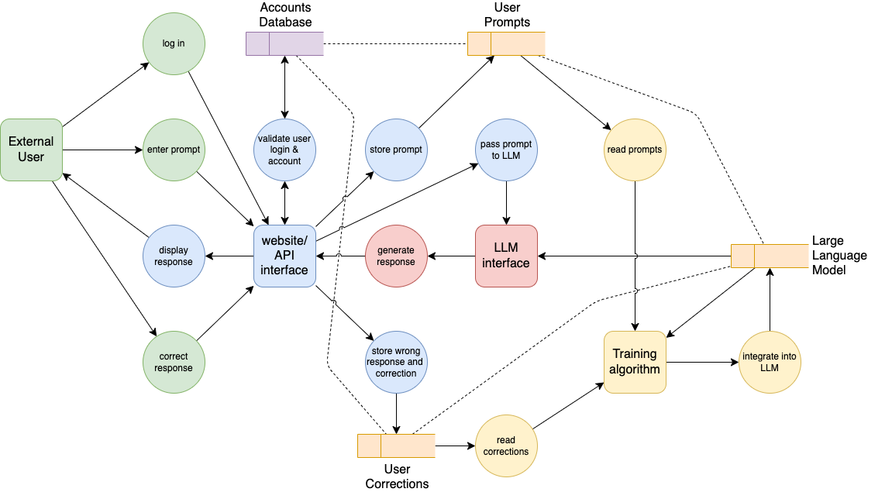

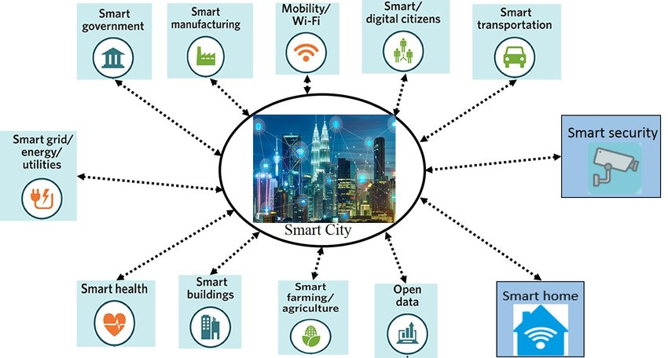

**Simplified smart city assistant data flow diagram**

**User Stories**

| **User Type** | **Functional Requirement (Epic)** | **User Story Number** | **User Story / Task** | **Acceptance criteria** | **Priority** | **Release** |
| --- | --- | --- | --- | --- | --- | --- |
| Customer (Mobile user) | Registration | USN-1 | As a user, I can register for the application by entering my email, password, and confirming my password. | I can access my account / dashboard | High | Sprint-1 |
|  |  | USN-2 | As a user, I will receive confirmation email once I have registered for the application | I can receive confirmation email & click confirm | High | Sprint-1 |
|  |  | USN-3 | As a user, I can register for the application through Facebook | I can register & access the dashboard with Facebook Login | Low | Sprint-2 |
|  |  | USN-4 | As a user, I can register for the application through Gmail | I can register and access the app using Gmail credentials. | Medium | Sprint-1 |
|  | Login | USN-5 | As a user, I can log into the application by entering email & password | I am redirected to the dashboard upon successful login. | High | Sprint-1 |
|  | Dashboard | USN-6 | As a user, I can access assistant modes like Eco-Query or Complaint Resolver. | Mode selection and interface load successfully. | High | Sprint-2 |
| Customer (Web user) | Web Interface Access | USW-1 | As a web user, I can log in and use the assistant via browser. | I can access the web dashboard and interact with the assistant. | High | Sprint-1 |
|  | Assistant Querying | USW-2 | As a user, I can ask sustainability-related questions via the web UI. | AI-generated responses are displayed promptly. | High | Sprint-2 |
|  | Complaint Resolver | USW-3 | As a user, I can submit civic issues via the web interface. | The complaint is categorized and routed automatically. | High | Sprint-2 |
| Customer Care Executive | Complaint Handling | USCCE-1 | As a care executive, I can view all civic complaints submitted by users. | A list of complaints is displayed with filters. | High | Sprint-2 |
|  | Complaint Status Update | USCCE-2 | As a care executive, I can update the complaint status (e.g., in progress, resolved). | Users can see updated complaint status. | Medium | Sprint-3 |
| Administrator | User Management | USA-1 | As an admin, I can manage user accounts (activate/deactivate users). | Admin can control access for all user roles. | High | Sprint-3 |
|  | Assistant Configuration | USA-2 | As an admin, I can configure assistant logic and department mappings. | The changes are reflected in assistant responses. | Medium | Sprint-4 |